The ImageCLEF Benchmark

Henning Müller, University of Applied Sciences Western Switzerland, TechnoArk 3, 3960 Sierre, Switzerland, henning.mueller@sim.hcuge.ch
Theodora Tsikrika, CWI, Amsterdam, The Netherlands, Theodora.Tsikrika@cwi.nl

Abstract

This text describes the ImageCLEF benchmark for multilingual, multimodal image annotation and retrieval. First, the general field of multimedia retrieval evaluation and the situation of ImageCLEF in this field are explained. Then, the ImageCLEF 2009 tasks, their objectives and the participation in these tasks are described. As of 2010 the format of CLEF (Cross Language Evaluation Forum) and ImageCLEF is changing; these changes are presented in detail to motivate readers of the IAPR (International Association for Pattern Recognition) newsletter to participate in CLEF and ImageCLEF 2010.

Introduction
In the 1990s, evaluation was clearly not one of the strong points of the multimedia retrieval domain but this has changed over the past ten years and benchmarking has become an important tool for advancing the field. The most well known benchmark is clearly TREC (Text REtrieval Conference, http://trec.nist.gov/) for information retrieval and TRECVid for multimedia (video) retrieval. CLEF (Cross Language Evaluation Forum, http://www-clef-campaign.org/) and its image retrieval part ImageCLEF (http://www.imgeclef.org/) have also become very popular over the past years with 190 registered users for CLEF and over 90 for ImageCLEF in 2009. Other benchmarks in multimedia retrieval include ImageEVAL for several imaging tasks, SHREC (SHape REtrieval Contest) for the retrieval of 3D objects and MIREX (Music Information Retrieval EXperiment) for music retrieval. In the IAPR, there are also two technical committees dealing with evaluation issues on several levels (IAPR TC12 and IAPR TC5, http://users.dsic.upv.es/~iaprtc5/).
ImageCLEF itself started with 4 participants in 2003 with a single photographic retrieval task and has since grown to over 90 participants in six different retrieval tasks. ImageCLEF was already described in the IAPR newsletter in early 2006 [1] where the tasks of ImageCLEF 2005 were presented and the ideas for ImageCLEF 2006 were outlined. Since then, ImageCLEF has become a much larger forum, from 15 participants in the 2005 workshop to over 60 ImageCLEF participants present in the CLEF 2009 workshop. The tasks have since become more varied, have deployed larger image collections, and have also created more realistic tasks and topics. The goals have remained the same in promoting multilingual and particularly multimodal (mainly image combined with text) retrieval, making modern retrieval techniques comparable, and showing the improvement in the field. The goal has always been to increase collection size but still retain a low entrance level to tasks so as to allow research groups without large supercomputing centers to participate without problems. A large number of the ImageCLEF participants are actually PhD students that obtain the possibility to compare their approaches with other groups and obtain a solid evaluation methodology at the same time, without wasting effort to create medium quality datasets and small ground truth data.

ImageCLEF 2009
With over 90 registrations, ImageCLEF set a new record in 2009 with 62 of these participants not only registering but also submitting results to at least one of the tasks. The ImageCLEF 2009 workshop hosted a large poster session for visual retrieval that fostered many lively discussions among the participants. With 6 tasks, there were also more tasks than ever before and this variety of tasks and collections led several participants to concentrate only on one or two of the available tasks. In the following subsections, the tasks are described in more detail.

Photographic Image Retrieval
In 2008 and 2009 the goal of the photographic retrieval task was to promote the diversity in retrieval results; therefore, besides precision, the so-called cluster recall was also measured, where images regarded as relevant to a query were clustered into groups, each group representing a different aspect of the query topic, and retrieval systems had to represent a maximum number of these clusters in the first results.
A new collection was made available in 2009 to the participants containing about 500,000 images made available by Belga news agency. This in itself is a challenge for many image retrieval systems but also means that a realistic size has been reached. Problems encountered with collections of this size are often fairly different from problems with collections of smaller sizes.
More on the photographic retrieval task can be read in [2].

Photographic Image Annotation
The photographic annotation task, a new task for 2009, used a small ontology for the annotation of images containing a hierarchy of 53 topics. 5,000 training images of a FlickR collection were distributed as training data and 13,000 as test data. An idea about the hierarchical structure of the ontology and the relationships can be seen in Figure 1.
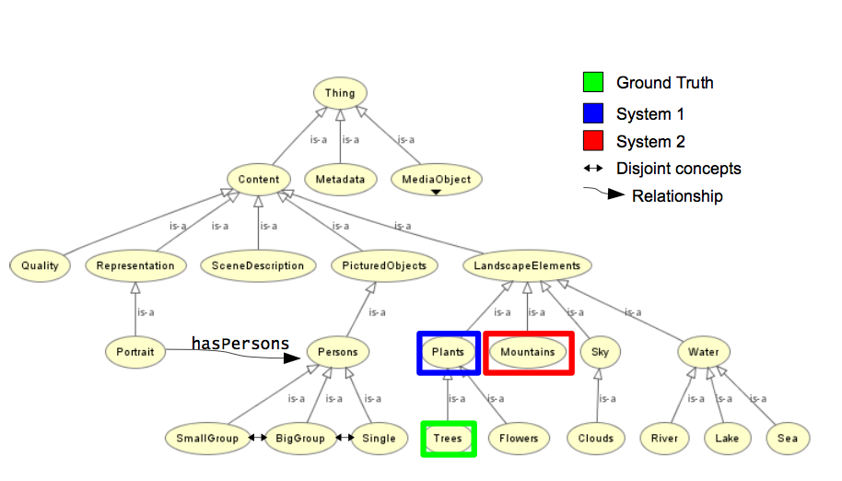
Figure 1 : Part of the hierarchy of the ontology and their relations.
A total of 20 groups participated in the task, and no text information in the images was available. More on the photo annotation task and also on the evaluation measures used can be read in [3].

Wikipedia Image Retrieval
The wikipedia image retrieval task distributed a collection of 150,000 images uploaded by Wikipedia users. The textual descriptions of the images in English were also distributed. Topics contained at least one image and a short query text. A total of 8 groups participated in the task and submitted over 50 runs. Topic generation, as well as the assessment for the creation of ground truth, were partly done collaboratively with the participants of the task.
More on the wikipedia retrieval task can be read in [4].

Robot Vision Task
The robot vision task was new in ImageCLEF 2009. The goal of the task was to learn places where a robot had taken pictures and then re-identify the place later when the robot passes again. The challenges include different lighting, changes in the places of the furniture and small modifications, for example people being temporarily in the room. Figure 2 shows example images from the task.
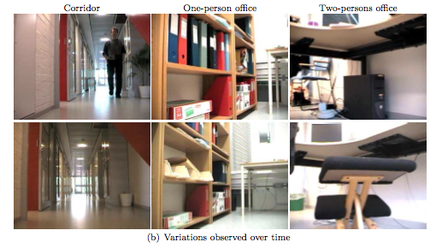
Figure 2 : Example images used for the robot vision task.
Seven groups finally submitted runs, with a large number of groups initially registering . More information on the robot vision task can be found in [5].

Medical Image Retrieval
In the medical image retrieval task of ImageCLEF 2009 a larger database of images and texts of medical articles of the scientific literature containing 85,000 images were made available to participants. The tasks were partly similar to tasks in previous years containing exact information needs based on a survey performed in Portland, OR, USA. 17 groups submitted runs. Textual techniques clearly outperformed visual techniques. A new task of case-based retrieval was introduced with 5 example topics. In this task a medical case including anamnesis, clinical data, images and a description of problems but no diagnosis were given to participants who had to find articles in the literature dealing with similar cases. The goal of this task was to bring the retrieval of medical images closer to clinical routine.
More information on the medical image retrieval task can be found in [6].

Medical Image Annotation
In the medical image annotation task, the classes and evaluation measures of the past four years of the task were distributed to participants including new test data. Groups were then expected to score the data of each year, also to show improvements compared to the earlier years of the medical image annotation task. Seven groups participated in the task and submitted runs. More on the medical image annotation task can be read in [7]
A second medical image annotation task focused on the detection and classification of lung nodules from 3D data sets in the medical DICOM format (Digital Imaging and Communication in Medicine). There was a large interest in the task but finally only two groups submitted results as the data and task were fairly challenging. This task is detailed in [6].

ImageCLEF 2010
For the past ten years, CLEF has been organized as a workshop at the European Conference on Digital Libraries (ECDL). As CLEF has grown in size with over 250 participants, the decision was finally taken to establish CLEF as an independent entity and with a clear conference structure that would give more room for the tasks presented and that would particularly add a scientific conference to CLEF giving the researchers the possibility to present scientific work. The next CLEF conference will thus be held over four days in Padova in 2010 (http://www.clef2010.org/). Two days will be dedicated to scientific discussions around evaluation in information retrieval with a focus on multilingual and multimedia issues. Two days will then be dedicated to labs, meaning the former CLEF evaluation tasks. For the first time tasks had to be accepted by an independent task selection committee, and ImageCLEF was accepted as one of five tasks, or evaluation laboratories as they are now called.
This new structure also has an influence on ImageCLEF as the reviewers underlined the need for a smaller number of tasks and increased aspects of multilinguality and language-independence. As a result four tasks were selected to be continued in 2010 based on their scientific interest and also based on organisers with the available manpower and resources. The four retained tasks are :
- a wikipedia retrieval task;
- an image annotation task;
- a robot vision task;
- a medical image retrieval task.
The popular photographic retrieval task will be discontinued due to a lack of man power but also due to a partial overlap with the wikipedia retrieval task. The wikipedia retrieval task will be made multilingual by adding descriptions in several languages. It will also become larger by crawling a new collection of Wikipedia images and have a stronger focus on imaging data and visual queries.
The image annotation task will be held using a similar ontology as in 2009, first year of the task. Again a database of FlickR is foreseen to be used and the 2009 data will be distributed as training data for the task.
The robot vision task will be changed from 2009, when the goal was mainly to detect the place where the robot took a particular picture. In 2010, it is planned to detect objects in the robot images as well, which links this task closer to the photo annotation task. Finding the place of a picture will still remain one of the goals of the task.
For the medical retrieval task, it is again planned to increase the size of the collection distributed to the participants, potentially including a larger number of different journals as well. Another major goal is to move the topics closer to clinical routine by having more case-based topics, i.e., topics where a medical case with several images is given without diagnosis and where articles treating similar cases need to found from the literature using text and visual information.
Registration for ImageCLEF 2010 is possible from the registration website at http://medgift.unige.ch:8080/CLEF2010/. It is also possible to submit scientific papers on evaluation topics to the main CLEF2010 conference.

Conclusions
ImageCLEF has become a popular platform for image retrieval evaluation that gives researchers the opportunity to discuss their techniques and compare performance on the same data sets and in the exact same framework. With the change of the CLEF format in 2010, we hope to create an even larger forum on visual information retrieval evaluation, as CLEF itself has traditionally been focusing on the text retrieval community. We hope that this article will motivate researchers to participate in the benchmark to really have a maximum of the state-of-art techniques in the field compare their performance on the same data and on the same tasks in order to advance visual information retrieval.

References
[1] Henning Müller, Paul Clough, The ImageCLEF Benchmark on Multimodal, Multilingual Visual Images, IAPR newsletter volume 28 number 2, April 2006.
[2] Monica Lestari Paramita, Mark Sanderson, Paul Clough, Diversity in Photo Retrieval: Overview of the ImageCLEFPhoto Task 2009, CLEF 2009 working notes, Corfu, Greece, 2009.
[3] Stefanie Nowak, Peter Dunker, Overview of the CLEF 2009 Large Scale - Visual Concenpt Detection and Annotation Task, CLEF 2009 working notes, Corfu, Greece, 2009.
[4] Theodora Tsikrika, Jana Kludas, Overview of the WikipediaMM Task at ImageCLEF 2009, CLEF 2009 working notes, Corfu, Greece, 2009.
[5] Barbara Caputo, Andrzej Pronobis, Patric Jensfelt, Overview of the CLEF 2009 Robot Vision Track, CLEF 2009 working notes, Corfu, Greece, 2009.
[6] Henning Müller, Jayashree Kalpathy–Cramer, Ivan Eggel, Steven Bedrick, Saïd Radhouani, Brian Bakke, Charles E. Kahn Jr., William Hersh, Overview of the CLEF 2009 Medical Image Retrieval Track, CLEF 2009 working notes, Corfu, Greece, 2009.
[7] Tatiana Tommasi, Barbara Caputo, Petra Welter, Mark Oliver Güld and Thomas M. Deserno, Overview of the CLEF 2009 Medical Image Annotation Track, CLEF 2009 working notes, Corfu, Greece, 2009.

